**Question 1: Opening multiple windows and reading the message from new window**

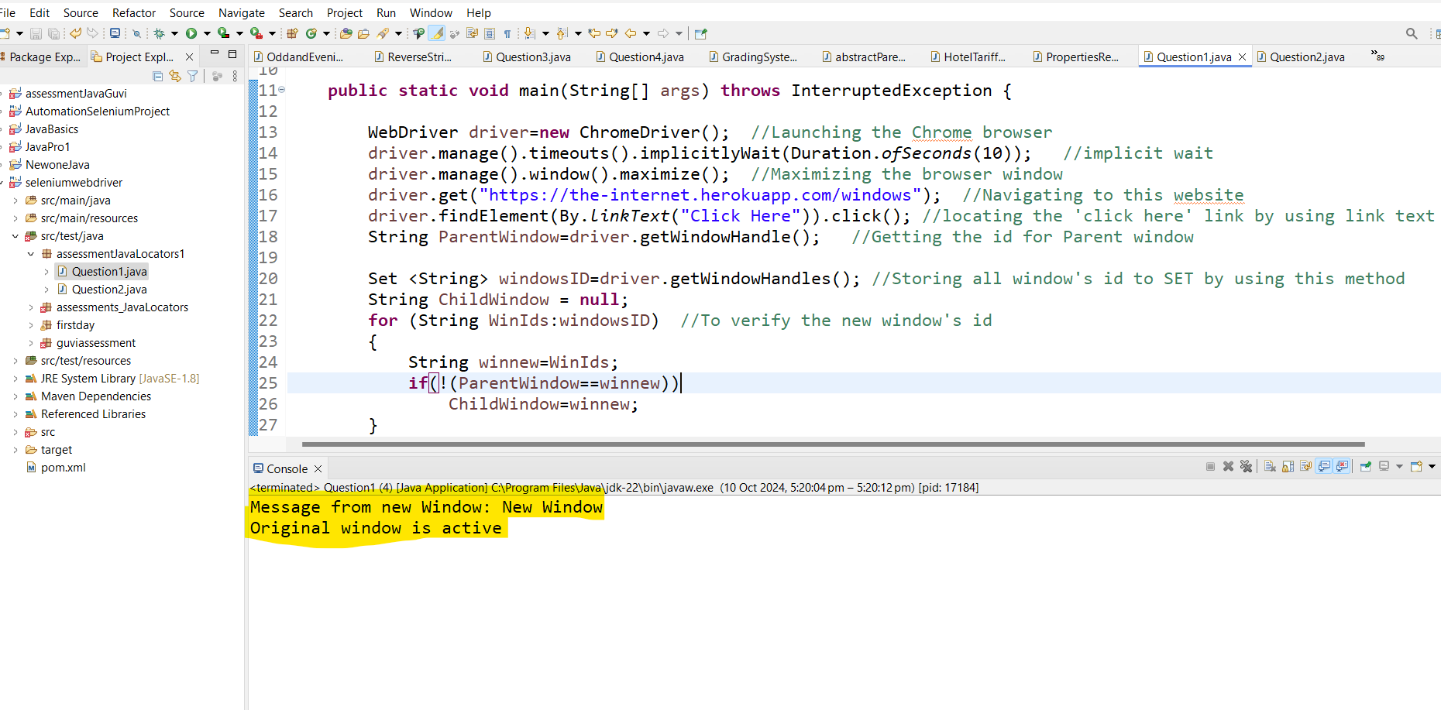

**Opening the with the Url: To click the ‘Click here’ in below window**

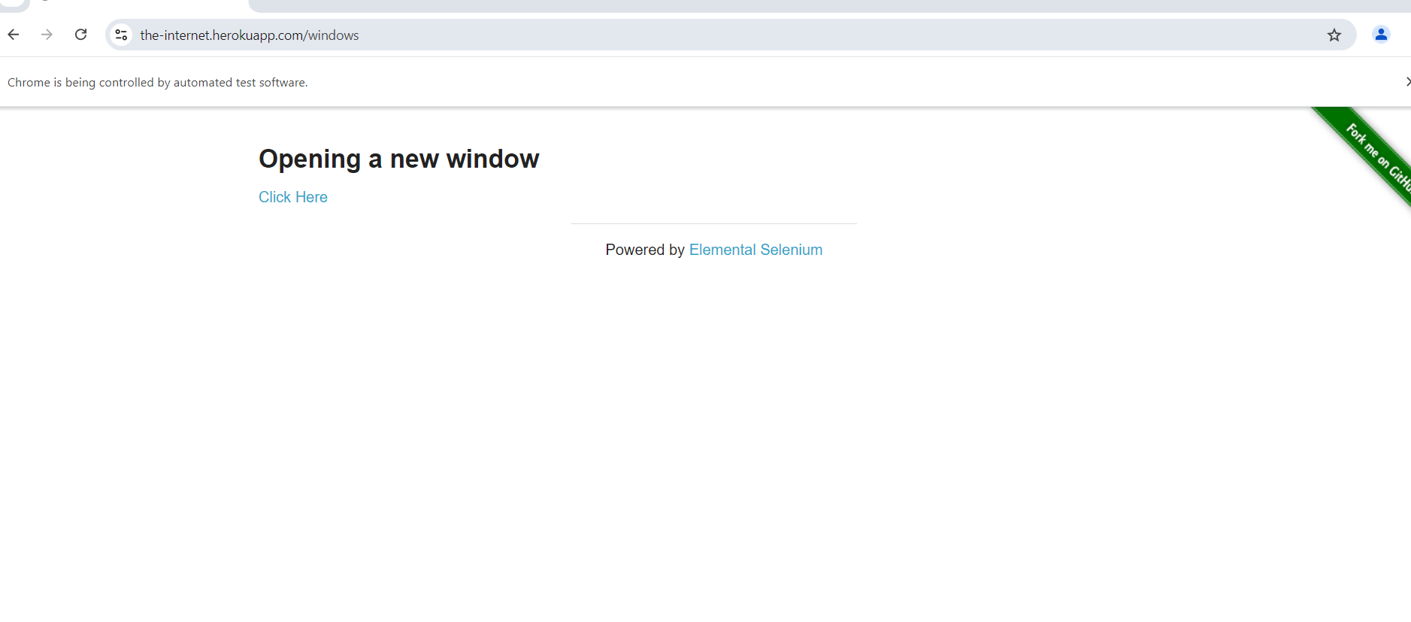

**Opened a new window in a new tab and reading the below message**

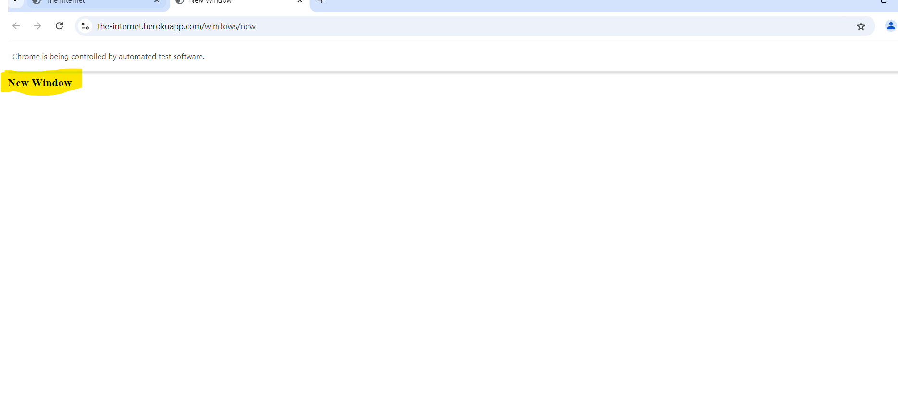

**After Closing a new window and switched into parent window**

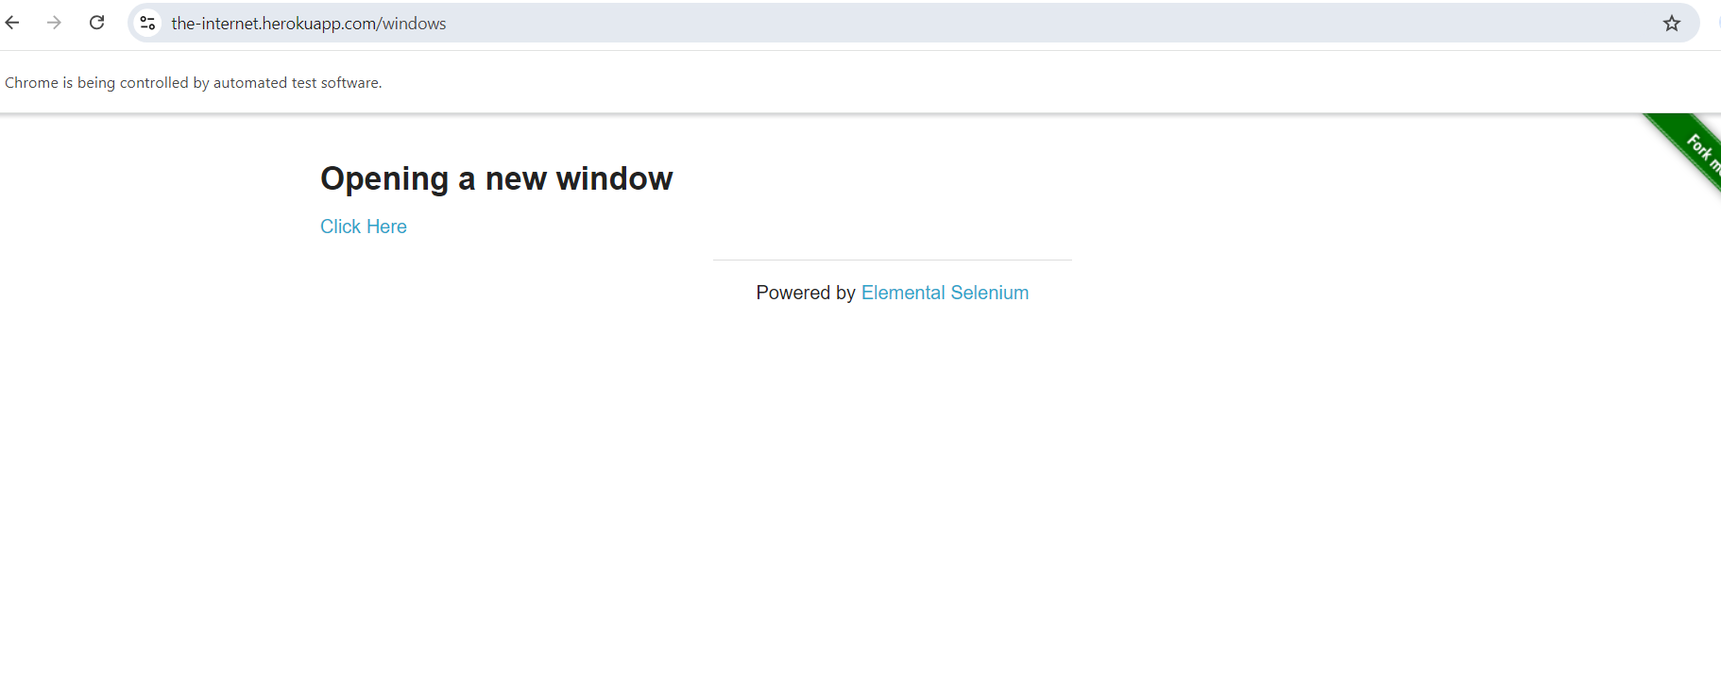

**Question 2: Traversing and reading the message from different/nested frames:**

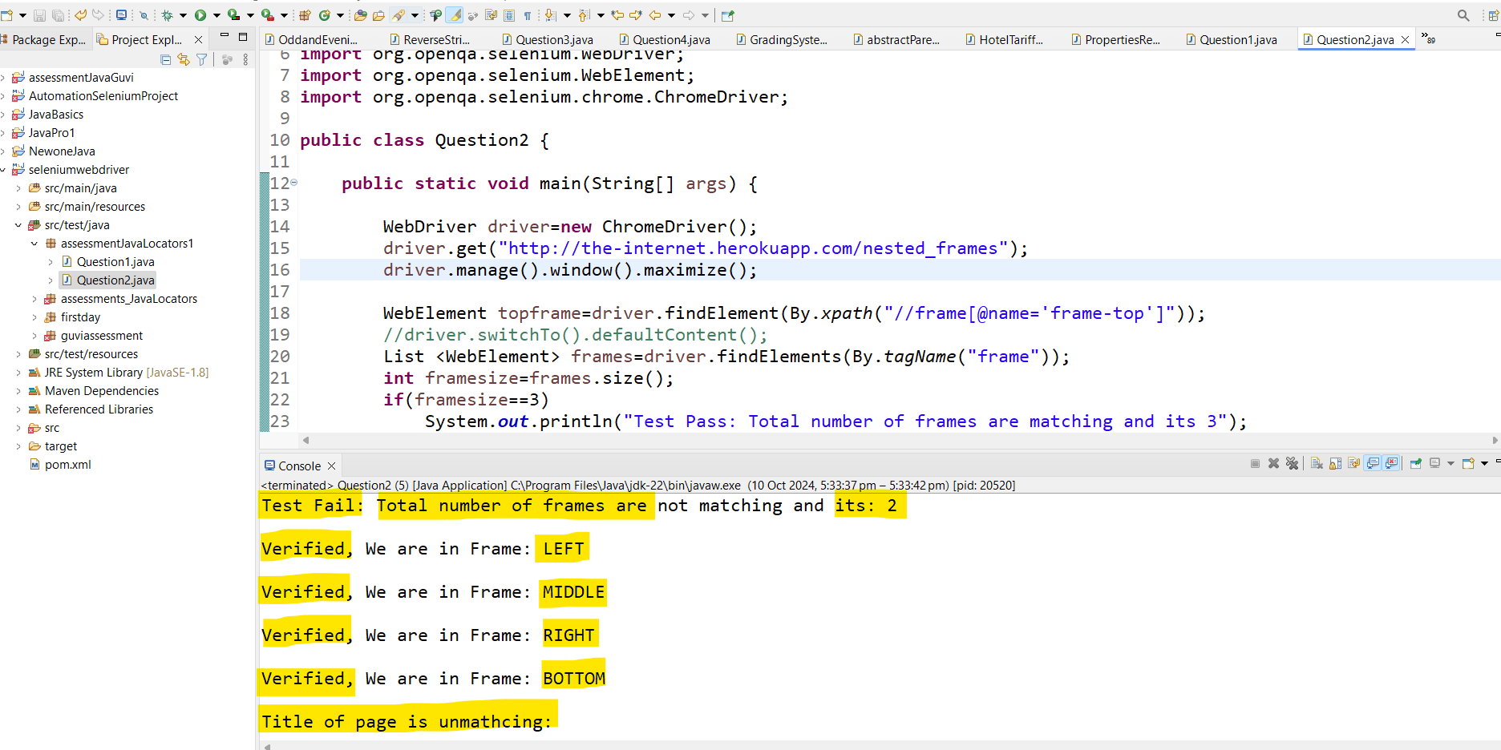

**Actual Frames window:**

